Principles of Management

Chapter 1
Managing in a Competitive World

Four ongoing challenges that characterize the business landscape:
- Globallization
- Technological Change
- Knowledge Management
- Collaboration

Globalization

- Today's enterprises are global, with offices and production facilities all over the world.
- Companies operate worldwide and a company’s talent and competition can come from anywhere
- Globalization affects small and large companies
- Many small companies export their products
- Globalization has changed the face of the workforce.

Technological Change
- Online customer engagement, AI, and machine learning, data protection and privacy, and 5G
- Technology drives down costs and accelerates globalization.
- It improves efficiency of decision-making.
- Challenges created by rapid changes.
- It's not all about the information technologies for example biology-based innovations transform the way we dress, and produce goods.

Knowledge Management

- Knowledge Workers: Workers whose primary contributions are ideas and problem-solving expertise.

- Knowledge Management: Finding, unlocking, sharing, and capitalizing on the most precious resources of an organizations:
- Expertise
- Skills
- WIsdom
- Relationships

Collaboration

- Collaboration requires productive communications among different departments, divisions, or subunits of organization
- Coopetition: simultaneous competition and cooperation among companies with the intent of creating value

Managing for Competitive Advantage

A key to understanding the success of a company is how well it both creates and sustains competitive advantage.
- Innovation
- Quality
- Services
- Speed
- Cost Competitiveness
- Sustainability

Innovation

A firm must:
- Adapt to changes in consumer demands and to new competitors.
- Continually innovate--especially important in the global marketplace.
- Innovation comes from the people and must be a strategic goal.

Quality

The excellence of your product

Historically quality referred to attractiveness, lack of defects, and dependability

Today it is about preventing defects before the occur, achieving zero defects in manufacturing, and designing products for quality

A philosophy of continuous improvement.

Service

Giving customers what they want or need, when they want it

Continually meeting the needs of customers and establishing mutually beneficial long-term relationships

Making it easy and enjoyable for the customer

Speed

Fast and timely execution, response, and delivery of products

Cost Competitiveness:

Keeping costs low to achieve profits and be able to offer prices that are attractive to consumers.

Companies must pay close attention to cost because consumers can compare prices from thousands of competitors

Sustainability

Minimizing the use and loss of resources, especially those that are polluting and nonrenewable

Management is the process of working with people and resources to accomplish organizational goals efficiently and effectively.

The Four Functions on Management

- Planning Delivering strategic value
  - Systematically making decisions about the goals and activities to be pursued

- Organizing Building a dynamic organization
  - Assembling and coordination resources needed to achieve goals

- Leading Mobilizing people
  - Efforts to stimulate high performance by employees

- Controlling Learning and Changing
  - Monitoring performance and making needed changes

Performing All Four Management Functions

A typical day for a manager is not neatly divided into the four functions.

Interruptions, meetings, and firefighting prevent a manager from smoothly tending to these functions.

Good managers devote adequate attention and resources to all four management functions

Management Levels and Skills

Top-Level

Middle-Level Managers

Frontline Managers

Exhibit 1.2

Must-Have Management Skills

Technical: The ability to perform a specialized task involving a particular method or process.

Conceptual and Decision: The skills related to abilities that help identify and resolve problems.

Interpersonal and Communication: Managers' people skills that represent the ability to lead, motivate and communicate efficiently to others.

You and Your Career

Emotional Intelligence (EQ):
The skills of understanding yourself, managing yourself, and dealing effectively with others.

Social Capital:
Goodwill stemming from your social relationships.
- Be both a specialist and a generalist
- Be self-reliant
- Connect with people
- Actively manage your relationship with your employer
- Survive and Thrive
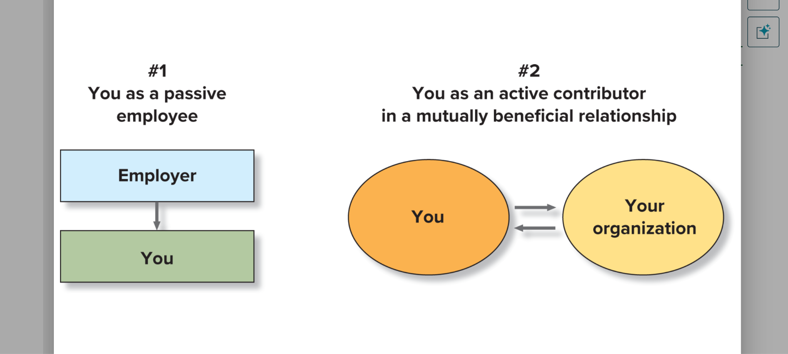

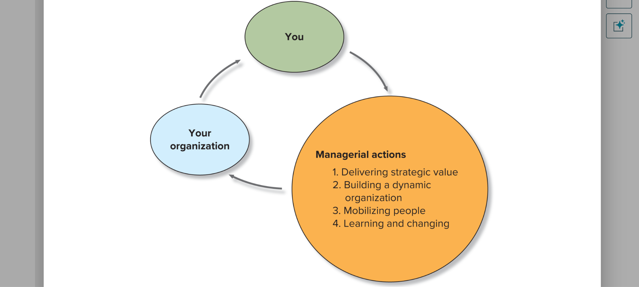

‘Common Practices of Successful Executives

- They convey to others “why we do what we do”
- They ask “What needs to be done?” not just “What do I want to do?”
- They write an action plan. They don't just think, they do, based on a sound, ethical plan.
- They take responsibility for decisions
- They focus on opportunities, not just problems

Delivering Strategic Value: Asking customer feedback
Building a dynamic organization: Communicating and referring to feedback with supervisor
Mobilizing people: Delegate and almost become a manager of others to meet the needs that come with the feedback
Learning and Changing: The worker will need to learn to actually now take feedback from the ones below and above him in his way, also learn how to manage others

Chapter 2

Open Systems
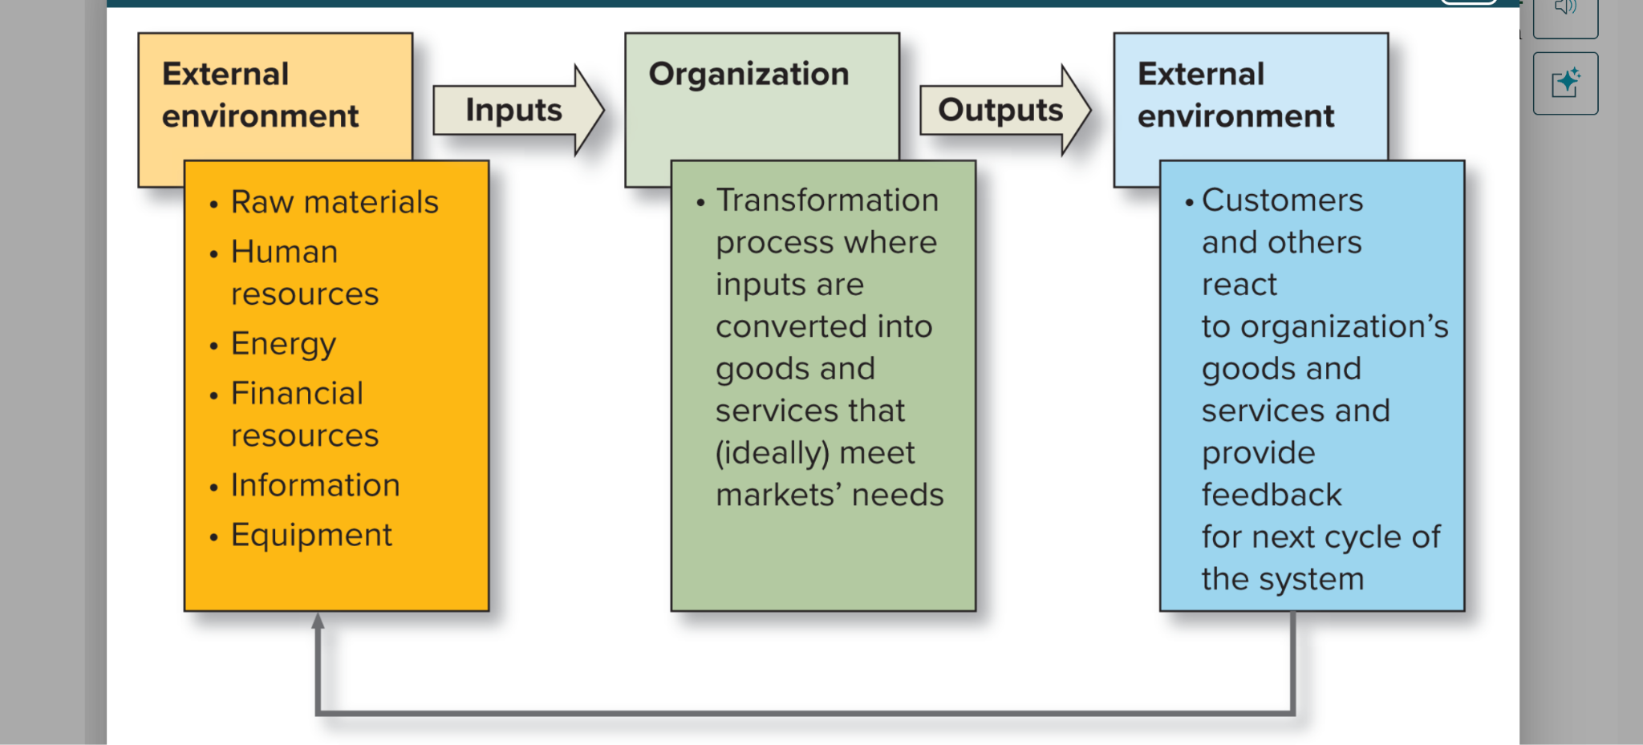

External Environment:
All relevant forces outside a firms boundaries, such as competitors, customers, the government, and the economy.

Competitive Environment
Include the firm and its rivals, suppliers, buyers, new entrants, and substitute or complementary products

Macroenvironment
affects all organizations; includes economic, technological, legal, demographics, and natural environment factors.
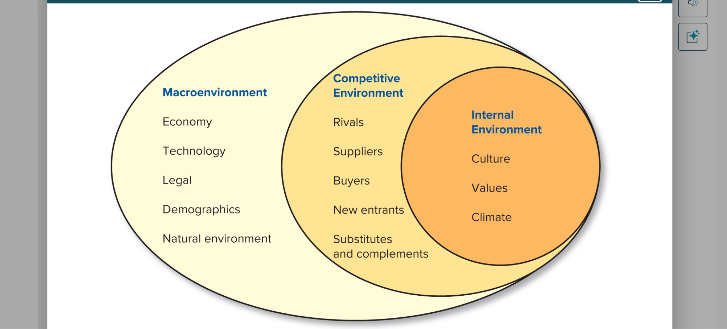

The Economy

The economic environment affects managers’ abilities to function effectively and influences their strategic choices

Managers and the Economy

Role of managers
- In publicly held companies, managers may feel required to meet wall street’s earnings expectations.
- Managers may focus on short-term results at the expense of long-term success.
- Some managers may be tempted to engage in unethical or unlawful behavior that misleads investors.
- Keep in mind that economic conditions change over time and are difficult to predict.

Technology

Technological advances create new products and services, advanced production techniques, and better ways of managing and communicating.
- As technology evolves, new industries, markets, and competitive niches develop.

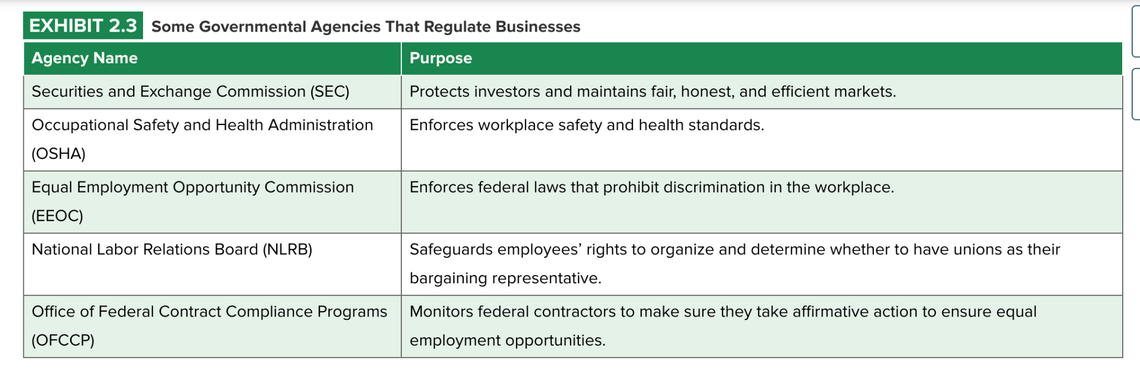

Demographics

Measures of various characteristics of people who make up groups or other social units.

Demographics trends:
- Aging of workforce
- Increasing education and skill levels
- Immigration factors
- Increasingly diverse workforce

Sustainability and the Natural Environment

Organizations depend on the natural environment to provide them with resources.
- Operations impact quality and quantity of resources.
- Impact the quality of life of citizens

Porters Model
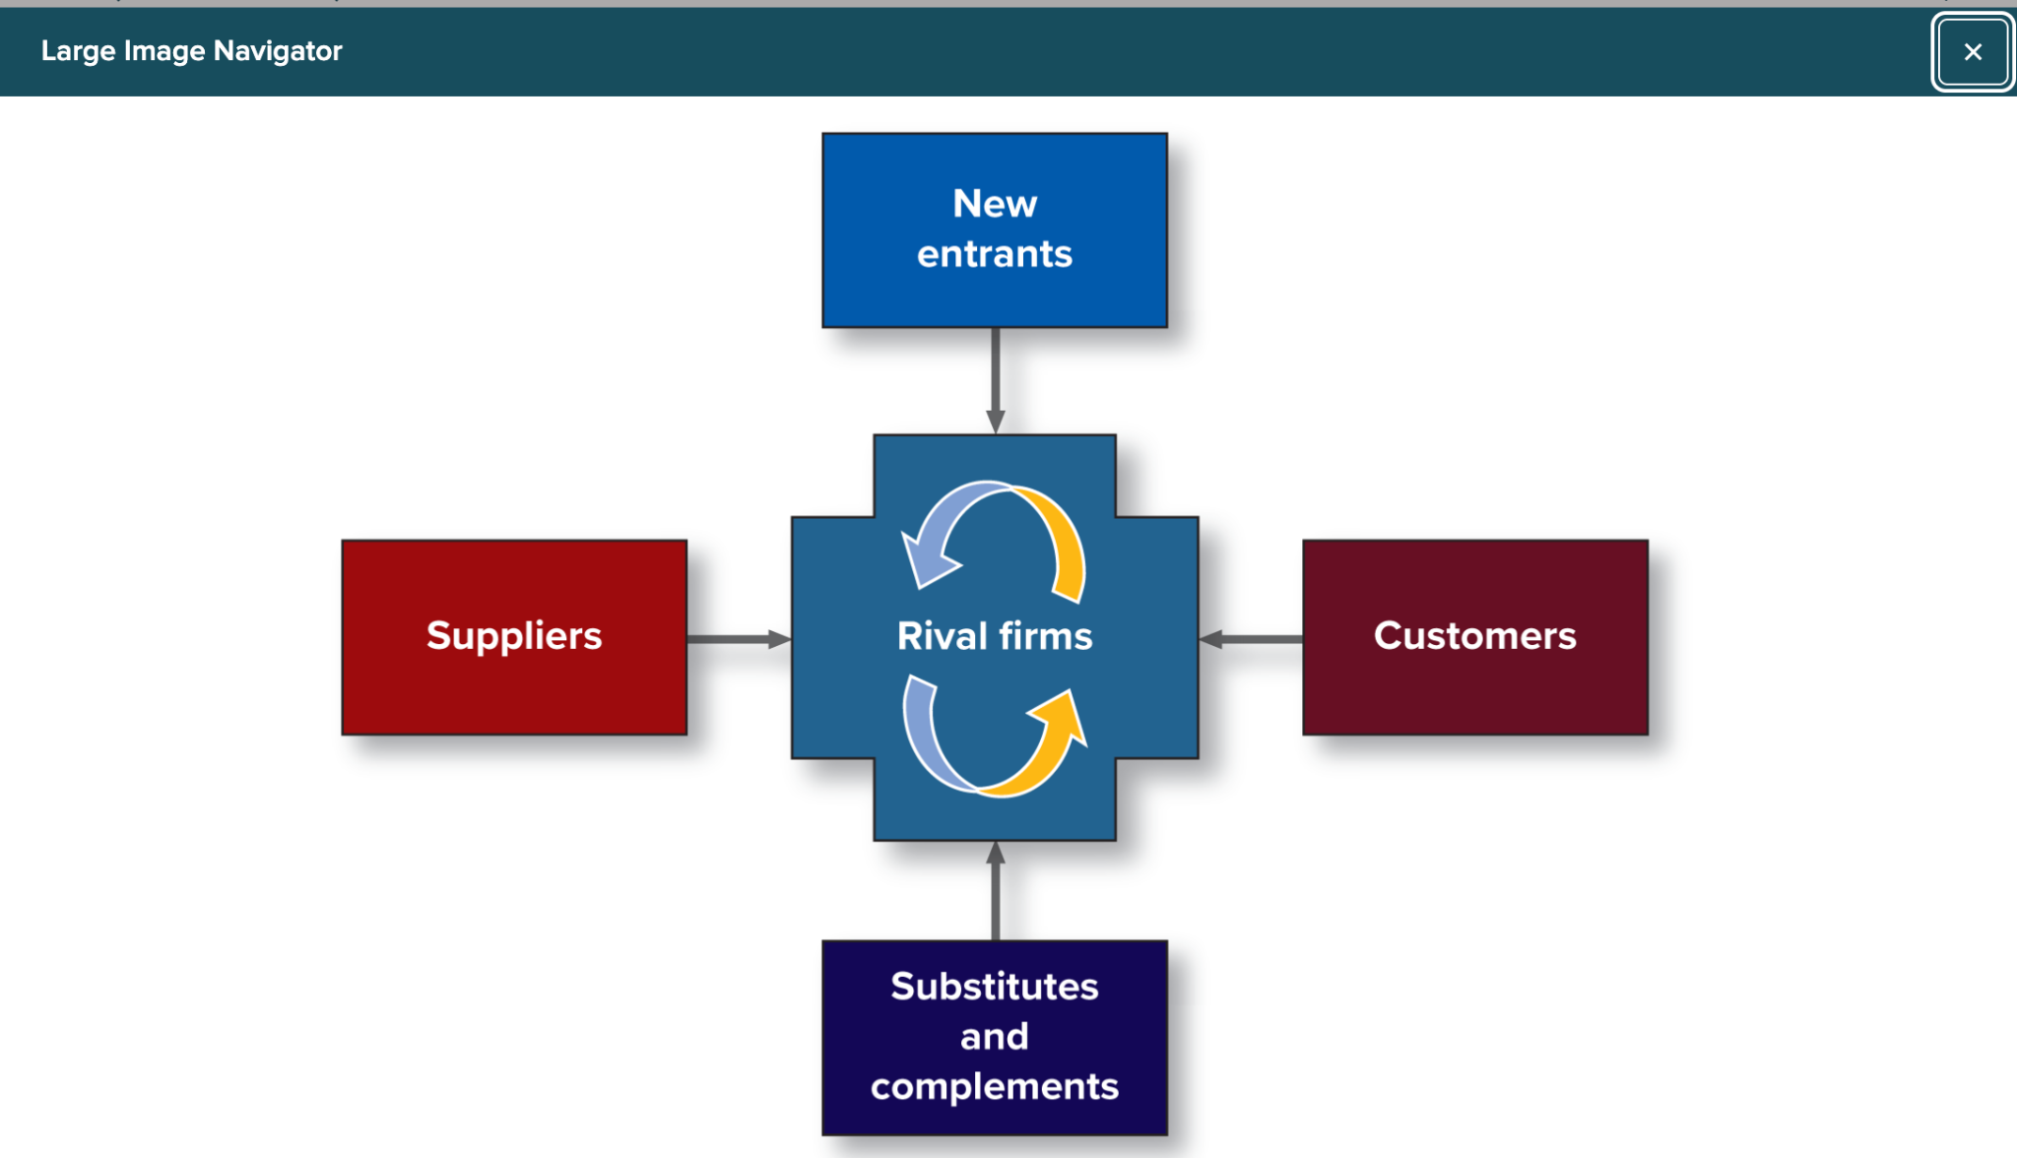

Competitors

Competition is most intense when:
- There are many direct competitors.
- Industry growth is slow.
- Product/service is not easily differentiated

When industry growth slows, profits drop causing a shakeout.
- Weaker companies are eliminated.
- Strong companies survive

New Entrants
Barriers to Entry:
- Conditions that prevent new companies from entering an industry.
- Government policy, capital requirements, brand identification, cost disadvantages, and distribution channels.
- New entrants must displace existing products with promotions, price breaks, intensive selling, and other tactics.

Substitutes and Complements

Substitutes
- Alternative products or service
- Potential threat
Complements
- Products or services that increase purchases of other products.
- Potential opportunity.

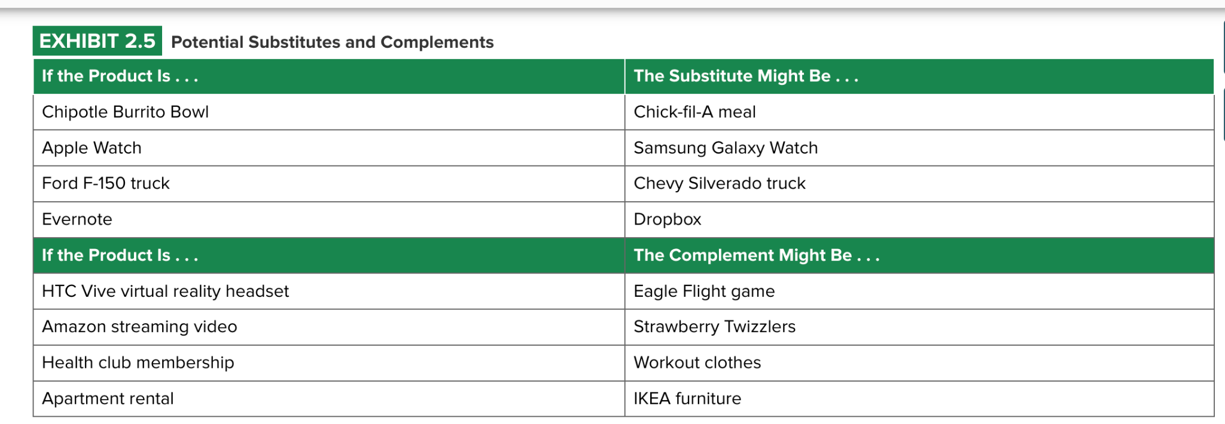

Suppliers

Supply chain management

- Also known as the extended enterprise.
- Managing the acquisition of materials, their transformation into products, and the distribution of products to customers.

Switching costs:

- The fixed costs buyers face changing suppliers.

Final Consumer
A customer who purchases products in their finished form.

Intermediate Consumer
A customer who purchases raw materials or wholesale products before selling them to final customers.

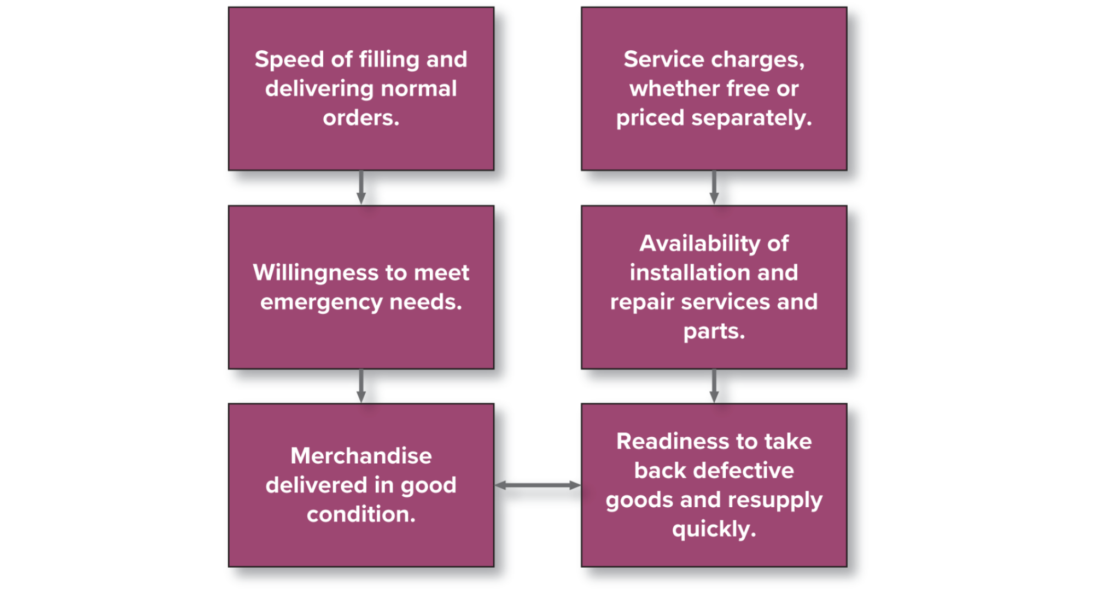

Environmental Analysis
Environmental uncertainty
Lack of information needed to understand or predict the future.

Environmental Complexity
The number of issues that must be attended to as well as the interconnectedness of these issues.

Environmental Dynamism
The degree of continuous change the occurs in a market

Environmental Scanning
Searching for useful information, unavailable to most, sorting that information and interpreting what is important.

Scenario
A narrative that describes a particular set of future conditions

Competitive intelligence
Information that helps managers determine how to compete better

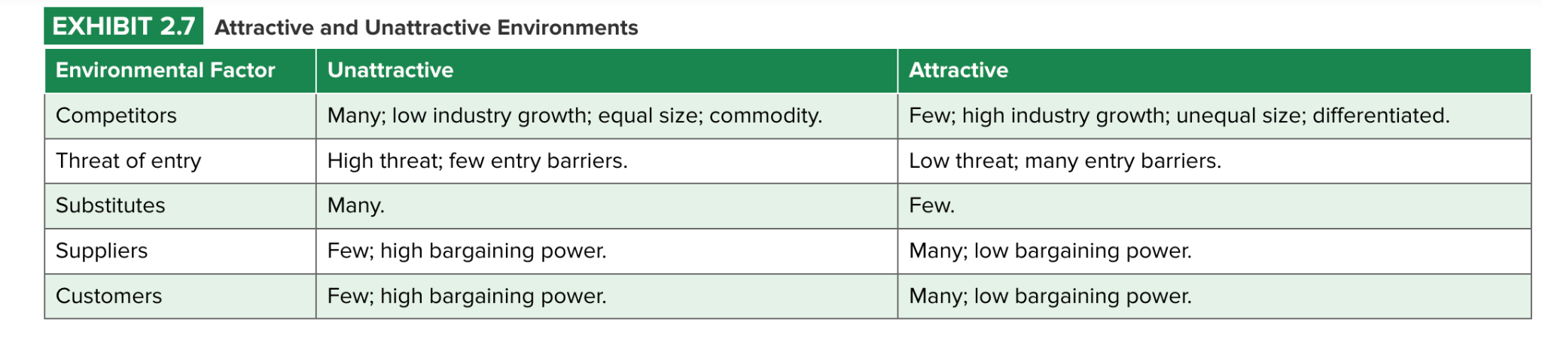

Scenario Development and Forecasting

Scenario Development
- Creates a narrative that describes a set of future conditions using forecasts and benchmarking
- Forecasts often include best-case and worst-case scenarios
Forecasting
- Method for predicting how variables will change the future

Benchmarking

The process of comparing an organization’s practices and technologies with those of other companies
- Identifying the best-in-case performance by one or more companies in a given area and comparing your processes to their processes.

Actively Managing the External Environment

Selecting your environment

Strategic maneuvering
- An organization’s maneuver around potential threats and capitalize on arising opportunities.

Domain selection
- Entrance to a new market or industry with an existing expertise.

Diversification
- Occurs when a firm invests in different types of businesses or products.

Mergers
- Two or more companies combine with another

Acquisitions
- One firm buys another firm

Divestiture
- A firm selling one or more businesses.

Defenders
- Companies that stay within a stable product domain as a strategic maneuver.

Prospectors
- Companies that continuously change the boundaries for their task environments by seeking new products and markets, diversifying and merging, or acquiring new enterprises.

Influencing your environment

Independent Strategies
- Strategies that an organization acting on its own uses to change some aspect of its current environment.

Cooperative Strategies
- Strategies used by firms who want to reach their objectives in cooperation with other firms through alliances and partnerships rather than by competing with them.

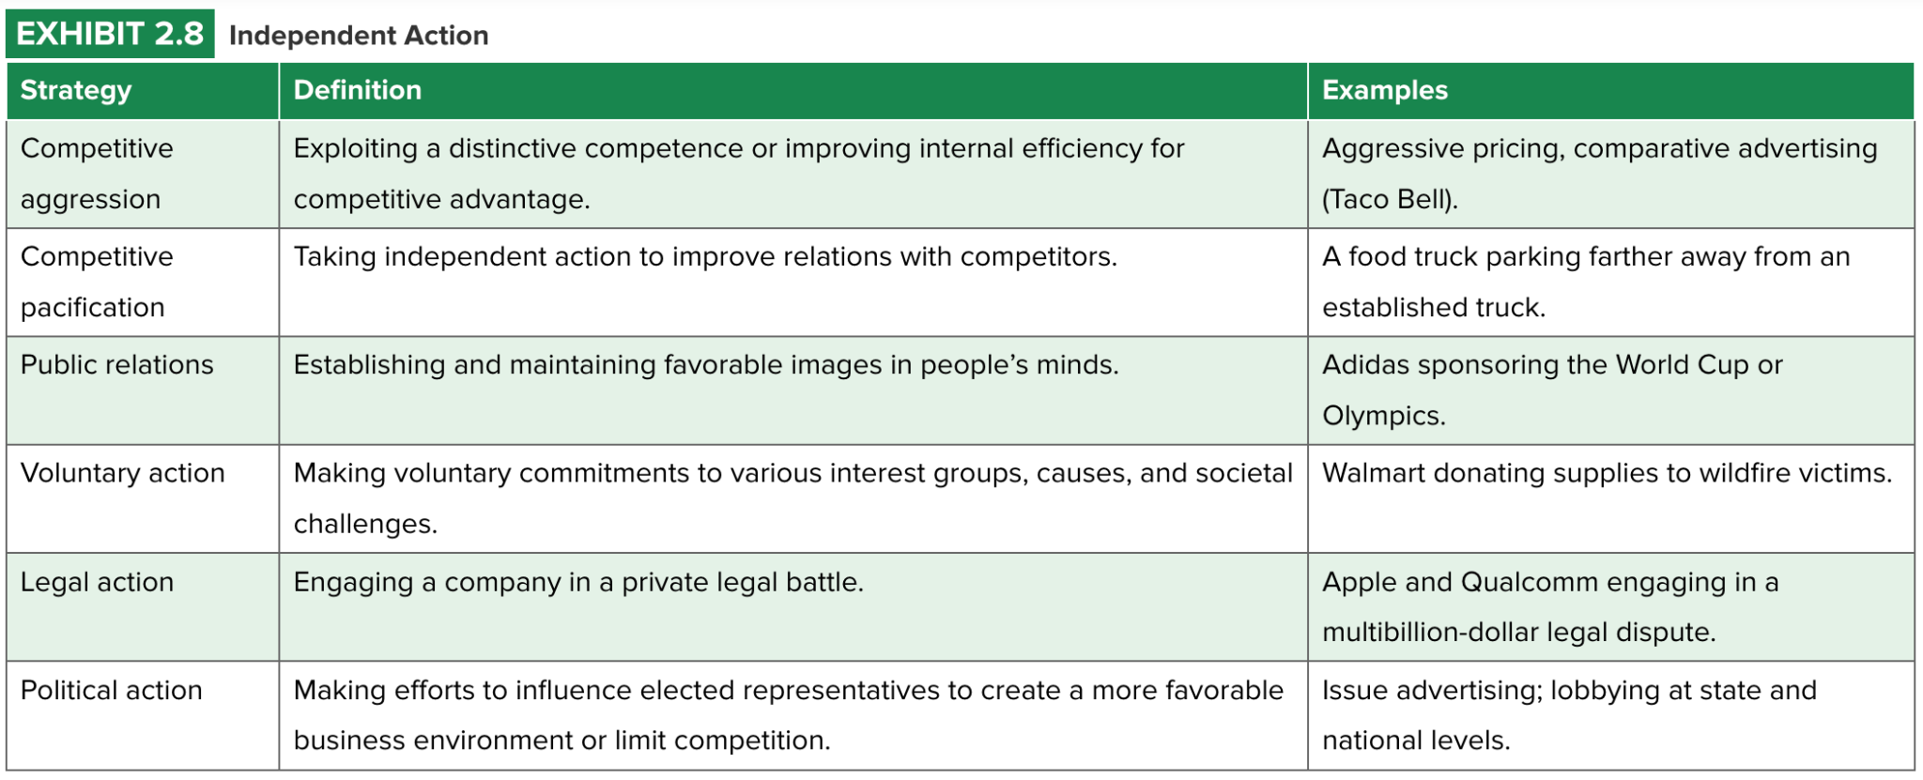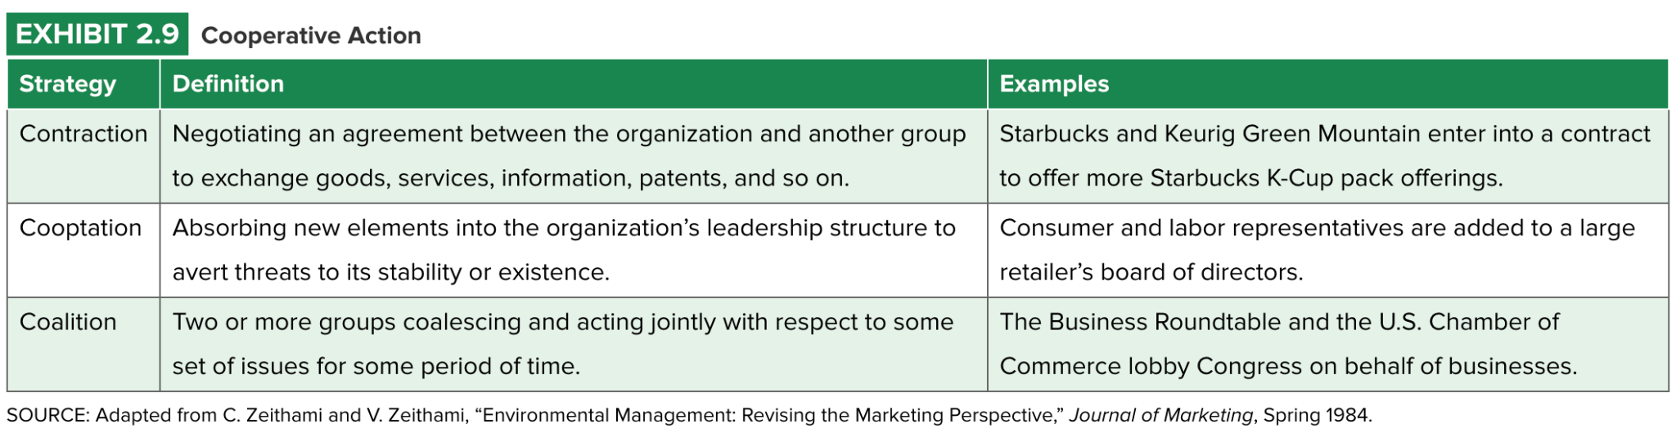

Buffering
- Creating supplies of excess resources in case of unpredictable needs.

Smoothing
- Leveling normal fluctuations at the boundaries of the environment.

Flexible processes
- Methods for adapting the technical core to changes in the environment.

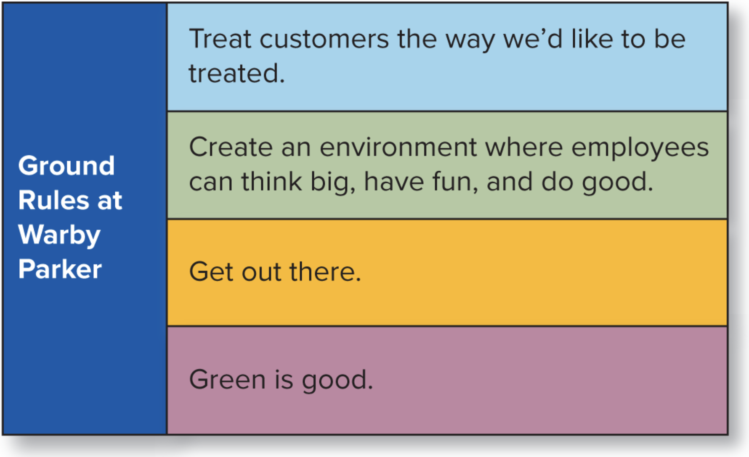

Organization Culture
- The set of important assumptions about the organization and its goals and practices that members of the company share

Managing Culture

- Manage culture actively
- Communicate with employees regularly and set the right examples
- Celebrate and reward those who exemplify desired culture

Chapter 3

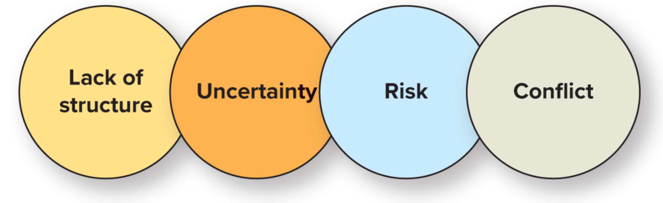
Lack of Structure

Programmed Decisions:
Decisions encountered and made before, having objectively correct answers, and solvable by using simple rules, policies or numerical computations.

Non-Programmed Decisions:
New, novel, complex decisions having no proven answers.

Uncertainty

Certainty
The state that exists when decision makers have accurate and comprehensive information.

Uncertainty
The state that exists when decision makers have insufficient information.

Risk
The state that exists when the probability of success is less than 100 percent and losses may occur.

Conflict
Opposing pressures from different sources, occurring on the level of psychological conflict or conflict between individuals or groups.

Levels of Conflict
- Individual decision makers
- Conflict between people
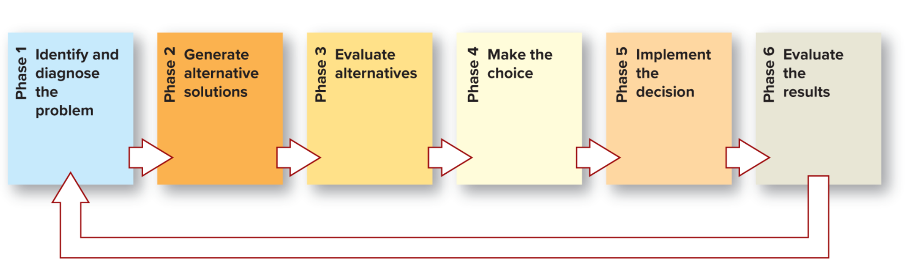

Maximizing
A decision realizing the best possible outcome.

Satisficing
Choosing an option that is acceptable, although not necessarily the best or perfect.

Optimizing
Achieving the best possible balance among several goals.

The Best Dicsions

Reflexive, A type of decision-making process that is reflexive and done quickly without careful thought.
Reflective, A type of decision-making process that is reflective and done slowly with deliberative thought.

Vigilance
A process in which a decision maker carefully executes all stages of decision making.

Barriers to Effective Decision Making

Motivated Reasoning
We see what we want to see, and make decisions based more on desire than on evidence

Confirmation Bias
People believe and accept incoming information that fits what they already believe, and ignore, distort, and reject information that doesn't confirm what they already think.

Illusion of Control
People’s belief that they can influence events even when they have no control over what will happen.

Framing effects
A decision bias influenced by the way in which a problem or decision alternative is phrased or presented.

Discounting the Future
A bias weighting short-term costs and benefits more heavily than longer-term costs and benefits.

Organizational Decisions Processes

Bounded rationality
A less-than-perfect form of rationality in which decision makers cannot be perfectly rational because decisions are complex and complete information is unavailable or cannot be fully processed.

Incremental model
Model of organizational decision making in which major solutions arise through a series of smaller decisions.

Coalition model
Model of organizational decision making in which groups with differing preferences use power and negotiation to influence decisions.

Garbage Can model
Model of organizational decision making depicting a chaotic process and seemingly random decisions.

Crisis Management (CM)
Process of identifying, preparing for, and dealing with potentially catastrophic threats to an organization.

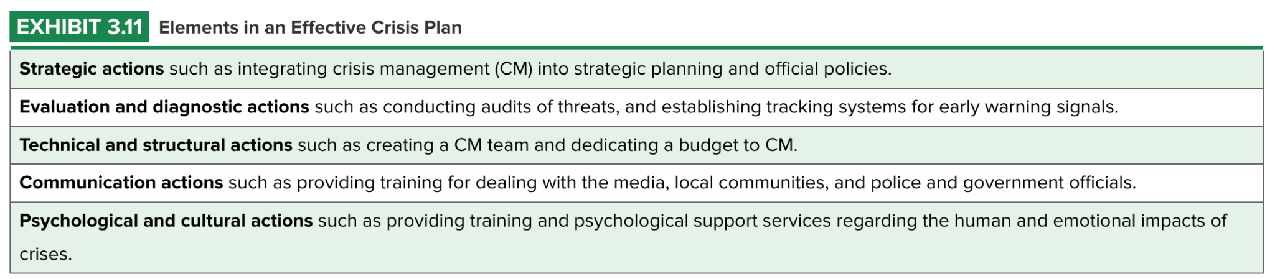

cognitive conflict
Issue-based differences in perspectives or judgments.

affective conflict
Emotional disagreement directed toward other people.

devil’s advocate
A person who has the job of criticizing ideas to ensure that their downsides are fully explored.

dialectic
A structured debate comparing two conflicting courses of action.

groupthink
A phenomenon that occurs in decision making when group members avoid disagreement as they strive for consensus.

goal displacement
A decision-making group loses sight of its original goal and a new, less important goal emerges.

